Assignment 1 (MOHAMED MUZAMMIL)

1. Create a user and make the user change their password upon the first login:

1. Create a file using the word "Linux" replace the word "Linux" with "Unix" and display the changed lines with line numbers:

1. How to check the user aging information:

1. how to check the CPU usage:

use the top command in Linux

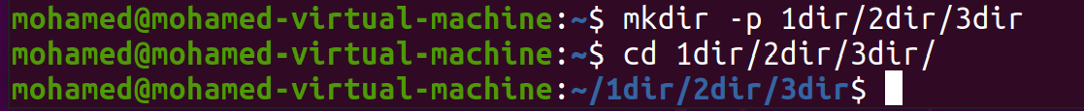 5. Create directories and sub-directories as follows in a single command:

6. Create a few files with different extensions and

a. find the files that have extensions .txt and display the number of files and only filenames.

b. Find the files which are modified 5 days ago and delete the files

7. Find the difference between two files

8. Create a file that has around 100 lines (Can have any content in that file)  
    a. Display the first 20 lines of the file

c. Display the line from 50 to 70 from a file.

9. Search recursively for a pattern in the directory